An Arduino and GSM based Fire Alert System

**By**

Israq Ahmed Anik

Roll: 15102013

&

Swarup Kumar Pal

Roll: 16102003

A project submitted in partial fulfillment of the requirement for the 3rd year promotion of the study of Bachelor of Science in Engineering



Department of Computer Science and Engineering

JATIYA KABI KAZI NAZRUL ISLAM UNIVERSITY, MYMENSINGH

PROJECT SUBMISSION YEAR, 2019

The project titled “An Arduino and GSM based Fire alert system” submitted by Student-Israq Ahmed Anik & Swarup Kumar pal , Roll No.: 15102013 & 16102003, Session: 2014-15 & 2015-16 , has been accepted as satisfactory in partial fulfillment of the requirement for the 3rd year promotion of the study in Computer Science and Engineering on Date-of-Defense.

BOARD OF EXAMINERS

|  |  |
| --- | --- |
| Signature |  |
| 1. Name of the Supervisor   Designation  Address | Chairman |
| Signature |  |
| 1. Name of the Internal Member   Designation  Address | Member |
| Signature |  |
| 1. Name of the Internal Member   Designation  Address | Member |
| Signature |  |
| 1. Name of the External Member   Designation  Address | Member  (External) |
| Signature |  |

CANDIDATE’S DECLARATION

We declare that this project is our own work and has not been submitted in any other form for another degree or diploma at any university of other institute of tertiary education. Information derived from the published and unpublished work of others has been acknowledged in the text and a list of references is given.

Date: Signature of the Candidates :

.............................................

.............................................

Name of the Candidates :

Israq Ahmed Anik

Swarup Kumar Pal

**Dedicated to**

This project is dedicated to our parents, who have done so much for us that we can’t express it in mere words, they have taught us so much over the years and we are forever grateful to them for it .

We wish them good health, and best of luck in their future endeavors..

Table of Contents

List of Figures vii

List of Tables ............................................................................................................ vii

Acknowledgement viii

Abstract ix

CHAPTER 1 Introduction 1

1.1 Introduction 1

1.2 Purpose of the Proposed System 2

1.3 Outline of the report 2

CHAPTER 2 : Necessity of the fire alert System 3

2.1 Effects of fire on people’s lives 3

2.1.1 Fire Extinguishers 3

2.2 Effects of fire on important materials 4

2.3 Effects of fire on environment 6

2.4 Fire in Bangladesh 7

CHAPTER 3 : Analysis of System Elements 10

3.1 Arduino Uno 10

3.2 Arduino IDE 11

3.3 GSM Module 12

3.4 Temperature Sensor 13

3.5 Red & Green LED 15

3.6 Buzzer 16

3.6.1 Buzzer Code 16

3.7 Breadboard 17

3.8 Jumper Wires 17

CHAPTER 4 : GSM Network 18

4.1 About GSM 18

4.2 GSM Module 18

4.3 Introduction to GSM Network 18

4.4 How GSM network works 19

4.4.1 GSM Code 19

4.4.2 Explanation 19

CHAPTER 5 : Design Of the System 20

5.1 Design Specification 20

5.2 Design Diagram 20

CHAPTER 6 : Implementation 21

6.1 System Setup 21

6.2 System Code 22

CHAPTER 7 : System Testing 25

7.1 Testing in case of NO Fire 25

7.2 Testing in case of Fire 26

7.3 Testing for sending SMS to mobile phone 27

7.4 Testing for calling to mobile phone 29

CHAPTER 8 : Result & Discussion 30

CHAPTER 9 : Conclusion 31

9.1 Scope 31

9.2 Limitation 31

9.3 Future Development 31

9.4 In Summary 31

References 33

List of Figures

Fig 2.1: The Chawkbazar fire incident ....................................................................... 3

Fig 2.2: Destroyed documents and material documents and material ........................ 5

Fig 2.3 : Fire’s effect on environment ........................................................................ 6

Fig 2.4.1: As fire engulfs the FR Tower in the capital’s Banani, some try to escape to safety ....................................................................................................................... 9

Fig 2.4.2: A six-story garment factory caught fire on may, 2013................................ 9

Fig 3.1: An Arduino Uno Board ............................................................................... 10

Fig 3.2: A screenshot from the Arduino IDE software ............................................. 11

Fig 3.3: A SIM900A module .................................................................................... 12

Fig 3.4 : LM35 Temperature sensor ......................................................................... 13

Fig 3.5: Connecting the LM35 sensor ...................................................................... 14

Fig 3.5: Green & Red LEDs ..................................................................................... 15

Fig 3.6 : B-10N Buzzer ............................................................................................. 16

Fig 3.7 : A Breadboard ............................................................................................. 17

Fig3.8 : Jumper Wires ............................................................................................... 17

Fig 5.2 : Theoretical Diagram of System .................................................................. 20

Fig 6.1 : System setup diagram ................................................................................. 21

Fig 7.1 : In case of no fire ......................................................................................... 25

Fig 7.2 : Testing in case of fire ................................................................................. 26

Fig 7.3 : A screenshot of Received message ............................................................ 28

Fig 7.4 : A screenshot of receiving a call from the GSM module ............................ 29

List of Tables

Table 2.4: financial loss in bd due to fire (2016-2017) ............................................... 7

Table 8 : Result of system testing ............................................................................. 30

# Acknowledgement

A project is a golden opportunity for learning and self-development. Many people deserve our cordial thanks for their help in completing this project. First and foremost, we would like to thank our honorable Supervisor Dr. A. H. M. Kamal, Professor, Dept. of CSE, JKKNIU who is so dedicated to help us in our times of need. We are really honored to make this project under his guidance who provides us his valuable time and knowledge, motivating thought and encouragement.

We would like to thank again Prof. Dr. A. H. M. Kamal, Head of the Dept. of CSE and Project Selection Committee for efforts and help provided to us to get such an excellent opportunity

# Abstract

Presently, communication is a very important part of our life. We can use this technology in a very sophisticated area like safety and security purpose. Using the GSM technology, communication can be conducive to save our life as well as households from fire accidents which have shown in this project. We design and develop an Arduino circuit with a temperature sensor, LED light, a buzzer and GSM module. When the temperature sensor detects fire (the detect measurement of fire can be configured regarding temperature and surroundings of the room), there are two LED lights which show the fire signal (when it is green ,there is no fire in the room and when it is green ,there is no fire in the room ) and the alarm rings immediately. Besides, there is a GSM module where a SIM card is installed and any phone numbers (as the demand of the visitor) are programmed. The SIM card sends message to the any phone numbers (as the demand of the visitor) that is programmed in the system. So, someone can be aware about the fire accidents even if he/she is not in home at the moment via SMS and Call.

# Introduction

## Introduction

Fire is a chemical reaction that gives us light and heat. Fire is useful, but also very dangerous because it can cause houses, factories and many other things to burn to ashes. Home can provide safety, convenience, and efficiency for people in the 21st century. Every year people die of fire accident . So, we need to find a feasible solution for the problem . Every day new technologies are being discovered. Our project can be used to reduce or even control fire related accident . We can implement it in big companies, factories and even in domesticated areas . Our project will help the development of economy of any country by protecting the houses, companies etc. Moreover, our project may save human lives from fire related accidents .

What we have designed , we have design a fire alert system that detects the fire form a mounted position in a room. By mounting it and making it into a fire monitoring system we can target only the fire and decrease the chance of collateral damage. Thus we ensure, we don’t have to worry about the fire becoming so intense and out of control that it can causes damage to life or the surrounding environment not only that also notifying and alerting the employees about the fire. The project is designed to search for a fire in a small floor plan of a house or room. This mission is divided into smaller tasks, and each task is implemented in the most efficient manner. The deployment of the device is implemented with a. along with these crucial tasks were other design constraints, such as the size, speed, and supply of power. Each defining characteristic of the system is described in more detail in this document. This project make use of modern communication technologies to deal with emergencies.

## Purpose of the Proposed System

The main purpose of the project is to develop a GSM based warning system for fire and send alert through SMS & call to the user . At past, we didn’t know where or when the fire is happened, but using this project we will know the time & the place of fire occurrence.

Fire alarm systems are important in providing occupants of buildings prompt warning if a fire occurs.

A fire alarm alerts you when you are busy, working or sleeping or not present on your property . You can therefore take action before major damage takes place, thus saving you the cost of property loss- also saving insurance companies a lot of damage cost. More than half of house fires take place in homes that do not have fire alarms, and mostly at night, resulting in a high number of deaths. It is easy to get trapped in the start of a fire .

## Outline of the report

Here we describe Nine(9) chapters on the purpose of this project. First we describe the introduction part that purpose of project, aim of the project. Chapter two contains necessity of the system where we describe about why fire alert system necessary. Then we analysis the project element . Where we describe about Arduino, GSM module, LED light etc. equipment which are used in this project. Then we briefly describe about the GSM module .Then we describe the system design and analysis where we show hardware and software design. Then we implement the project. After that, we show the output of this project using tested the project. We end it with result discussion and reference part .

# : Necessity of the fire alert System

## Effects of fire on people’s lives

At least 16,000 incidents of fire have occurred around the country in the last 10 years, killing 1,590 people and injured many more injured. This project can play a vital role in life safety. Automated Fire alert systems are the most effective means of fire controlling. When properly installed this system can be highly effective safe-guard against loss of life and property.

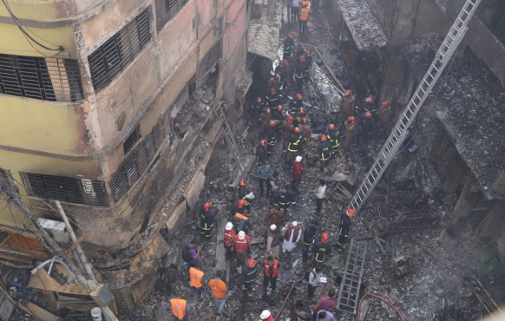

Fig 2.1: The Chawkbazar fire incident .

Fire is an essential to human life but it can cause many disastrous accidents , we can combat them by using precaution and also ways to stop fire from spreading , we can use fire extinguishers for that , and they are explained below .

### Fire Extinguishers

Fire extinguishers are elements that can be used to extinguish fire , and they are :

#### Water fire extinguishers

Water fire extinguishers are good for putting out flames on carpets and soft furnishings, but are dangerous when used on flammable liquids or cooking fats. This is a good device to have in the bedroom and living room, especially if you are a smoker, but not useful for the kitchen.

#### Foam extinguishers

Foam extinguishers are effective on woods and flammable liquids, petrol and spirits but not for kitchen or electrical fires, making this a handy device to keep in the garage.

#### Carbon-di-oxide (CO2)

Carbon-di-oxide (CO2) is effective on flammable liquids and electrical fires, but not suitable for cooking fats or soft furnishings.

#### Dry powder

Dry powder can be used on the widest range of fires in the home. It is safe to use on textiles, wood, flammable liquids/gases and electrical fires. However it cannot be used on kitchen fires involving cooking fats and oils. It’s a good device for garages and living areas, but you will still need a separate device for the kitchen.

#### Wet chemical

Wet chemical is safe to use on soft furnishings and cooking fat fires, yet hazardous when brought into contact with electrical or flammable gases and liquids. It is good for the living room and kitchen but unsuitable for the garage.

#### Fire blanket

Fire blanket is a handy item to have in cooking areas and can stop small pan fires from spreading. They are mounted on the wall and easily accessible: using a fire blanket is the best and quickest way to extinguish a pan fire. They can also be used to wrap around people when their clothing has caught fire.

But all can prevent fire when you know exactly where the fire is happened. So, using this system we can know exactly where fire is on.

So we can use any of those Extinguisher in occurrence of fire in our system .

## Effects of fire on important materials

The most prevalent threat faced by all cultural institutions is FIRE. No institution is immune from fire. Until the owners/trustees of these institutions develop plans for dealing with the fire threat, they place the building and its occupants, visitors, and collections at risk. The complexity of these plans may vary from a simple evacuation plan, to a fire prevention program, to a more complex plan that includes passive and automatic fire protection systems.

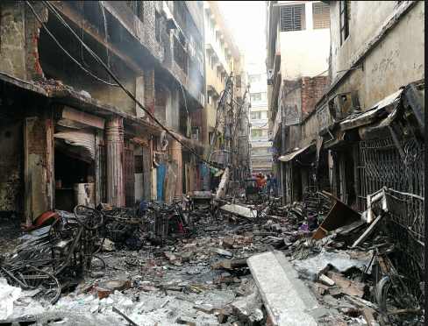

Fig 2.2: Destroyed documents and material .

Property damaged by floods can often be dried out and restored. Structural damage from an earthquake might be repaired. Stolen property always has a chance of being recovered. Damage from fire, however, is usually permanent and irreparable. Historical buildings or contents, once reduced to ash, can never be restored. Fire is more cunning and less discriminating than a thief. It can travel (spread) through very small openings and concealed spaces to reach other parts of a building, deprive occupants of a life supporting environment, and cause partial to total destruction of property.

There exists a cavalier attitude in this country that "fire won’t happen to me," that" it is someone else’s problem." Americans also place a lot of blind faith in their local fire department to save them and their property from any fire that may occur, and believe insurance will cover the rest. Reality is very different, and our daily fire statistics bear this out .

To provide some additional insight, a 2019 White Paper from Worcester Polytechnic Institute reported on the use of fire extinguishers to combat real fires in academic settings. According to their research, fire extinguishers are used approximately 15,000 times each year in schools, colleges, universities, dormitories, fraternities, sororities and barracks.

That means that fire extinguishers are called into service more than 41 times each day as the first line of fire defense in our nation’s schools.

In office and educational institutions, fire can destroy all the important documents, papers, and other important materials. Thus, Our Fire alert system can protect these important elements from being burnt by extinguishing fire at early stage .

## Effects of fire on environment

Fire is often associated with negative impacts on the environment. We usually think of the damage and devastation fire causes to wildlife and vegetation, but a fire event can also be beneficial for our plants and animals.

To be sure, the leading cause of global warming remains overwhelmingly the burning of fossil fuels. That warming lengthens the fire season, drying and heating the forests.

All can prevent fire when you know exactly where the fire is happened. So, using this system we can know exactly where fire is placed and plays a vital role in protecting the environment.

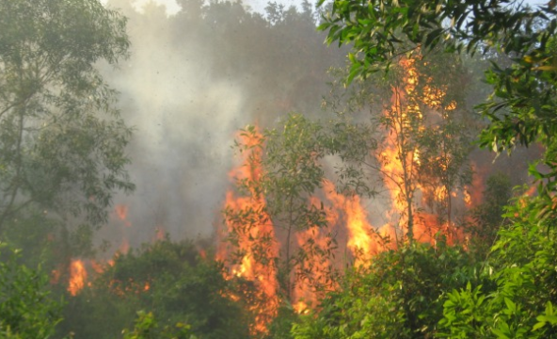

Fig 2.3 : Fire’s effect on environment.

## Fire in Bangladesh

Urban fire incidence is alarmingly increasing all over Bangladesh particularly in larger Urban centers. Due to rapid unplanned urbanization and the absence of adequate safety measures in the city system, Dhaka City is seriously facing this hazard at present.

At present, Dhaka is serving the role of a metropolis with over 20,283,55 people and Also serving the role of the national capital for 167,997,176 of Bangladeshis (worldometer ,2019) . The national urban population share of Dhaka city was 25% in 1981, 31% in 1991 and 34% in 2001 respectively 37.2 % of the population is urban 2019.(Wikipedia,2019)

Supreme Court lawyer Syeda Rizwana H said in 2019 **:**

***“****The number of fires has increased more than threefold across Bangladesh since 1997; with the year 2018 seeing a daily average of 53. At least 16,000 incidents of fire have occurred around the country in the last 10 years, killing 1,590 people****”***

The horrific Nimtoli fire, which killed 124 people – 11 from the same family – in 2010, and the Chawkbazar fire that killed 71 people in February 2019 .

Both cases, investigations revealed that the fires were caused and took devastating form because of the unregulated chemical warehouses in Old Dhaka. After the Nimtoli fire, the government directed the warehouse owners to move their businesses, but the order has not been implemented in the last 2010, In fact, no legal step has been taken against the owner of the chemical warehouse that caused the Nimtoli fire. With an area of 1,050 acres, Old Dhaka has 24,000 buildings divided among 11 wards of Dhaka South City Corporation (DSCC). Most of those buildings are not Rajuk-approved .

The area is highly congested, with a population density of nearly 1,100 persons per acre. In such a populated and risky area, there are nearly 15,000 chemical warehouses. According to Bangladesh Fire Service and Civil Defence , at least 468 fire incidents were reported in Lalbagh , Hazaribagh, Sadarghat and Siddikbazar areas of Old Dhaka in 2018 alone. Some of the survivors of the Chawkbazar fire were present at the hearing.

In the last year there has been more than one fire a week, according to figures compiled in Bangladesh by the American Center for International Labor Solidarity. The statistics are based on reports in the local media and from their network of affiliated union groups .

The following year, 52 people were killed and 247 injured in 16,858 fires, while 45 people killed and 269 injured in 18,105 fires the following year.

However, the number of casualties marked a sharp rise last year as 130 people were killed and 664 were injured in 19,642 fires. When contacted, urban planning expert and former University Grants Commission (UGC) Chairman Prof Nazrul Islam said:

***“****Usually fires are triggered by an electric short-circuit, gas and other burners, cigarettes, gas cylinders, technological devices, inflammable objects, or chemicals.****”***

Sometimes, miscreants set fire to houses or shops—and other establishments—out of animosity. In many cases, the public's callousness and lack of awareness are responsible for fires. Public awareness can significantly reduce the number of fires. The use of gas cylinders in vehicles, houses, and restaurants has now become a major worry and the government should increase its monitoring in this regard to tackle the problem.

The urban expert said the government will have to intensify its disaster management and prevention activities in urban areas as well as launch a countrywide campaign to raise awareness about the causes of fire.

|  |  |  |  |
| --- | --- | --- | --- |
| **Year** | **Countrywide Fire** | **Financial Loss** | **Casualty /injury** |
| 2016 | 16,858 | 240 crore 43 lakh | 152/247 |
| 2017 | 1,845 | 35 crore 81 lakh | 14/41 |
|  |  |  |  |
| **Year** | **Dhaka city Fire** | **Financial Loss** | **Casualty /injury** |
| 2016 | 3,020 | 100 crore 63 lakh | 15/81 |

**Table 2.4: financial loss in bd due to fire(2016-2017)**

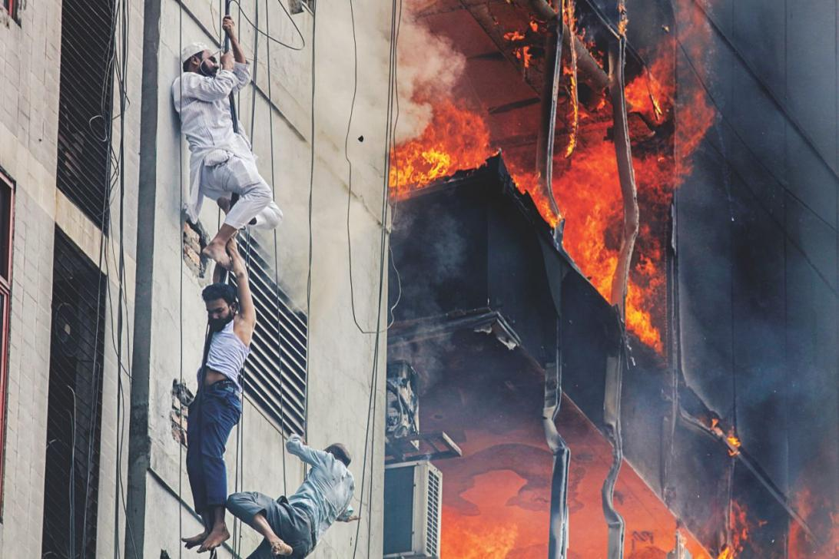

**Fig 2.4.1: As fire engulfs the FR Tower in the capital’s Banani , some try to escape to safety .**

**At least 19 people were killed and around 100 others injured in march,2019as a deadly fire tore through 22-storey FR Tower in the capital's Banani area.**

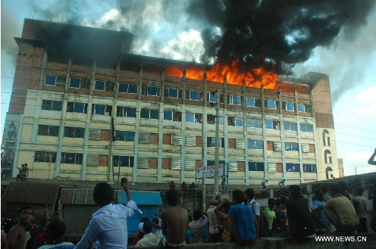

**Fig 2.4.2: A six-story garment factory caught fire on may, 2013.**

**The motivation towards working on this research and development program was originated from the view of massive fire occurrence in Bangladesh and it is increasing rapidly day by day. The existing fire alert system is not working according to our needs. So, we wanted to establish our innovative idea and make more feasible and reliable system. Thus we can reduce losses than before and protect human life and property.**

# ****: Analysis of System Elements****

In this experiment we are going to use a total of 8 elements and they are explained below :

1. Arduino Uno

2. Arduino IDE software

3. GSM module

4. Temperature Sensor

5. Red & Green LEDs

6. Buzzer

7. Breadboard

8. Jumper Wires

Those parts are explained in further value with how to program them and use them with codes below

## ****Arduino Uno****

**Arduino Uno is a microcontroller board based on the ATmega328P (datasheet). It has 14 digital input/output pins (of which 6 can be used as PWM outputs), 6 analog inputs, a 16 MHz quartz crystal, a USB connection, a power jack, an ICSP header and a reset button. It contains everything needed to support the microcontroller; simply connect it to a computer with a USB cable or power it with a AC-to-DC adapter or battery .**

**"Uno" means one in Italian and was chosen to mark the release of Arduino Software (IDE) 1.0. The Uno board and version 1.0 of Arduino Software (IDE) were the reference versions of Arduino, now evolved to newer releases. The Uno board is the first in a series of USB Arduino boards.**

**There is a software called “Arduino IDE” which is essential to the arduino, and used to program the arduino and push that software onto the arduino.**

**To start the project first we need to connect the arduino to a PC, using the included data connector which provides power supply to the arduino , and see how the software is used .**

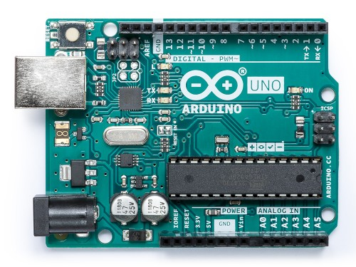

**Fig 3.1: An Arduino Uno Board .**

## ****Arduino IDE****

The Arduino IDE is the software used to program the Arduino . The IDE stands for “Integrated Development Environment” , it is a cross-platform application (for Windows, macOS, Linux) that is written in the programming language Java.

The Arduino IDE supplies a software library from the Wiring project, which provides many common input and output procedures.

For example in this project we are going to use GSM Module , and Arduino IDE provides software libraries for that module too.

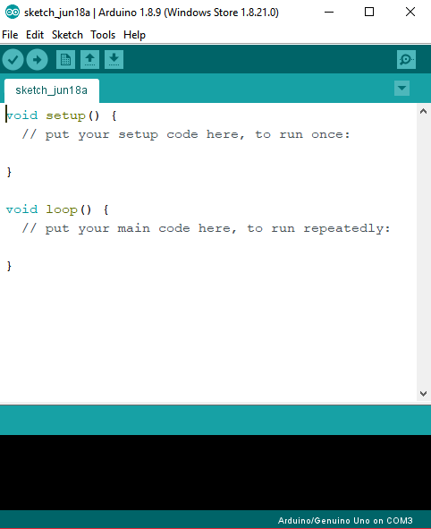

**Fig 3.2: A screenshot from the Arduino IDE software .**

## ****GSM Module****

**GSM stands for Global System for Mobile Communications, originally Groupe Special Mobile, is a standard developed by the European Telecommunications Standards Institute (ETSI) .**

**It was created to describe the protocols for second-generation (2G) digital cellular networks used by mobile phones and is now the default global standard for mobile communications – with over 90% market share, operating in over 219 countries and territories.**

**A GSM module or a GPRS module is a chip or circuit that will be used to establish communication between a mobile device or a computing machine and a GSM or GPRS system.**

**In this project we use the SIM900A GSM module for our convenience, as it’s cheap and reliable than most other GSM modules.**

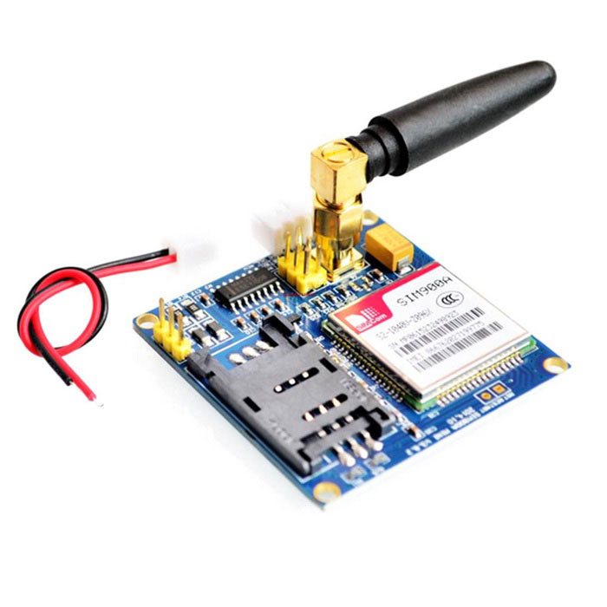

**Fig 3.3: A SIM900A module .**

**The SIM900A module works with 5v input , which we can supply from the Arduino, and to communicate with the arduino we can connect two(2) digital pins of arduino with the RX & TX of the SIM900A module .**

**Further more is explained in the GSM Network chapter .**

## ****Temperature Sensor****

**A temperature sensor is a device, typically, a thermocouple or RTD, that provides for temperature measurement through an electrical signal. A thermocouple (T/C) is made from two dissimilar metals that generate electrical voltage in direct proportion to changes in temperature.**

**In this project we are going to use ICs as some of them behave like a temperature sensor, Here we are going to use the LM35 IC.**

**The LM35 series are precision integrated-circuit temperature devices with an output voltage linearly-proportional to the Centigrade temperature. As the LM35 device draws only 60 µA from the supply, it has very low self-heating of less than 0.1°C in still air. which makes it perfect for our project .**

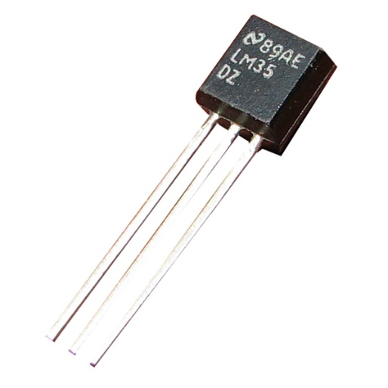

Fig 3.4 : LM35 Temperature sensor.

Now we are going to program that sensor , to get the output in temperature , for that we connect the sensor to the arduino like the below diagram and open the IDE for programming the sensor .

After opening the ide we write a code for the arduino that will get us the temperature in Celsius, in the serial monitor.

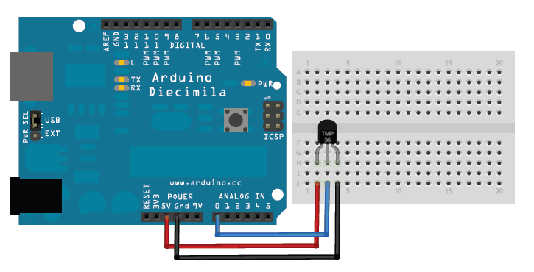

**Fig 3.5: Connecting the LM35 sensor.**

**After connecting the sensor as shown in the figure , with the arduino we push the below code to the arduino .**

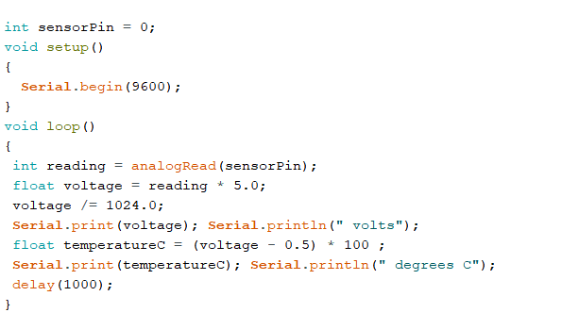

**from here we can see that the temperature sensor is giving us temperature output in celsius ( °C ) .**

## ****Red & Green LED****

**LED stands for light Emitting Diode. A light-emitting diode (LED) is a semiconductor light source that emits light when current flows through it. Electrons in the semiconductor recombine with electron holes, releasing energy in the form of photons. This effect is called electroluminescence. The color of the light (corresponding to the energy of the photons) is determined by the energy required for electrons to cross the band gap of the semiconductor. White light is obtained by using multiple semiconductors or a layer of light-emitting phosphor on the semiconductor device.**

**For our project we are going to use two LEDs , one is green and one is red , green will light up when there’s no fire and red will light up incase of fire.**

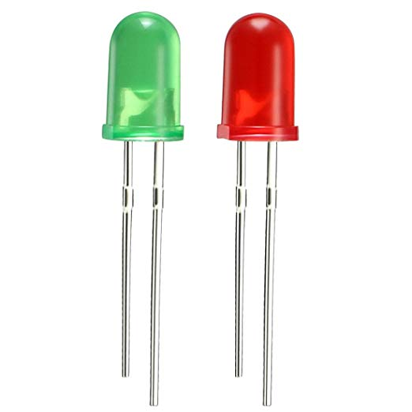

**Fig 3.5: Green & Red LEDs.**

**We are using LEDs instead of a display as it’s cheap , more power efficient and easy to understand , thus even an illiterate person can identify the case of danger when fire happens by identifying the red led powering on .**

## ****Buzzer****

A buzzer or beeper is an audio signaling device, which may be mechanical, electromechanical, or piezoelectric (piezo for short).

In this project we are going to use piezoelectric buzzer , specifically the B-10N model .

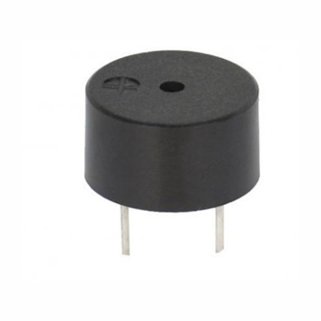

**Fig 3.6 : B-10N Buzzer**

### Buzzer Code

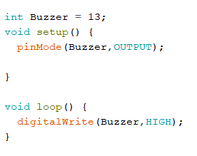

This is a sample code for a working buzzer, after connecting the buzzer to the 13th pin and pushing this code into arduino, we would be able to hear the buzzer go off .

The important part is to connect the arduino ground to the negative of the buzzer(meaning the short pin) , and the other to the 13th pin .

## Breadboard

A breadboard is a solderless device for temporary prototype with electronics and test circuit designs. Most electronic components in electronic circuits can be interconnected by inserting their leads or terminals into the holes and then making connections through wires where appropriate.

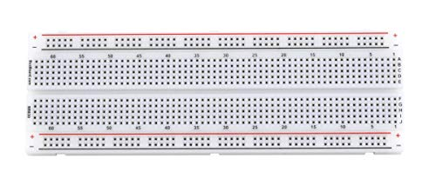

Fig 3.7 : A Breadboard.

## ****Jumper Wires****

Jumper wires are simply wires that have connector pins at each end, allowing them to be used to connect two points to each other without soldering. Jumper wires are typically used with breadboards and other prototyping tools in order to make it easy to change a circuit as needed.

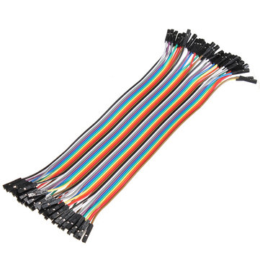

Fig3.8 : Jumper Wires.

# : GSM Network

## About GSM

GSM (Global System for Mobile communication) is a digital mobile telephony system that is widely used in Europe and other parts of the world. GSM uses a variation of time division multiple access (TDMA) and is the most widely used of the three digital wireless telephony technologies (TDMA, GSM, and CDMA). GSM digitizes and compresses data, then sends it down a channel with two other streams of user data, each in its own time slot. It operates at either the 900 MHz or 1800 MHz frequency band.

## GSM Module

GSM/GPRS module is used to establish communication between a computer and a GSM-GPRS system. Global System for Mobile communication (GSM) is an architecture used for mobile communication in most of the countries. A GSM/GPRS MODEM can perform the following operations:

* Receive, send or delete SMS messages in a SIM.
* Read, add, search phonebook entries of the SIM.
* Make, Receive, or reject a voice call..

## Introduction to GSM Network

GSM was originally known as Group Special Mobile but nowadays it is commonly referred as Global System for Mobile Communication. It is a set of standards developed by the European Telecommunications Standards Institute (ETSI) used to describe the protocols for second generation digital cellular networks used by mobile device, commonly referred as 2G technologies. One of the key features of GSM is the SIM (Subscriber Identity Module). Global System for Mobile Communication (GSM) is the world’s most popular standard for mobile telephony systems. GSM is used by over 1.5 billion people all over the world. GSM also pioneered the low cost implementation of the Short Message Service (SMS) which allows parties to exchange delay tolerant short text messages. It can also make calls. The popularity and coverage of cellular networks allows the use of SMS service and call service.

In this project we use the SIM900A GSM module for our convenience, as it’s cheap and reliable than most other GSM modules.

## How GSM network works

### GSM Code

Now we try to make a call using the SIM900A module , for that we have to go to the Arduino IDE and white some code to make a call .

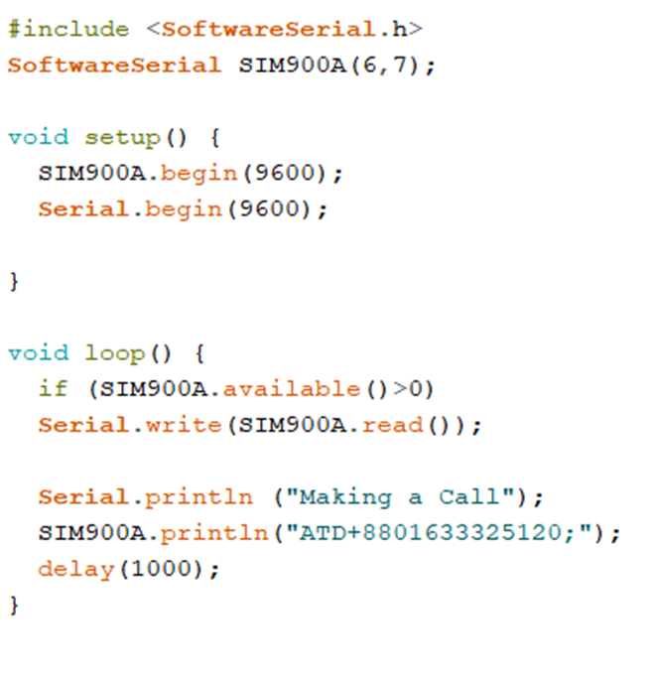

### Explanation

In this code we can see the use of Software Serial .h header file , which is used to access the GSM module libraries. and pin 6 & 7 are TX & RX .

We use SIM900A.begin(9600); to set the baud rate of the GSM .

For calling the “ATD” command is used, in the code we seen the use of “ATD” command SIM900A.println("ATD+8801633325120;");

This program will let the Module to call the number +8801633325120 repeatedly.

Here, In the GSM module(SIM900A) ,we uses a sim inside the module which number is (+8801309912871).when coming a call from (+8801309912871) which is indicate fire alert in the recipient phone number (+8801633325120).

We can use any number that send the call recipient phone number in the country when fire is on or any chances of fire (above 40`) .

# : Design Of the System

In this portion of the report we are going to discuss how we designed the system in details .

## Design Specification

The system design is the primitive step to the development of any system. Systems design is the process of defining the architecture, components, modules, interfaces, and data for a system to satisfy specified requirements. Systems design could be seen as the application of systems theory to product development. There is some overlap with the disciplines of systems analysis, systems architecture and systems engineering A well-designed system is a key to the existence of that system in the marketplace.

This system has been designed with keeping in mind the following key requirements-

* The server network should be accessible from anywhere .
* Clients should be able to quickly and seamlessly receive the alert message .
* A SIM card of user should be registered .
* In case of fire it will alert the user about the fire .
* Hardware’s should be compatible with each other.

## Design Diagram

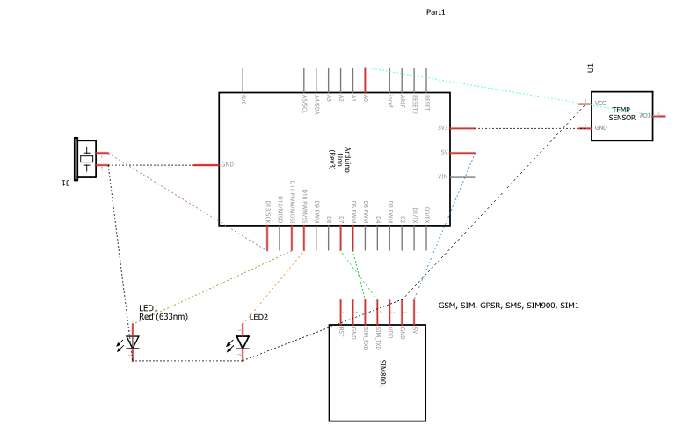

Fig 5.2 : Theoretical Diagram of System .

# : Implementation

Implementation refers to the construction of the proposed system with the specified design in a procedural manner.

In this part of the report we are going to talk about the implementation of the System and how we did it.

## System Setup

Here we are going to discuss how the system has been set up . Firstly as our system is a GSM based system , we need to connect the GSM to the Arduino first . to do that , we supply power from the arduino to the GSM , by connecting Arduino 5V to GSM Vcc and Arduino Ground to GSM ground .

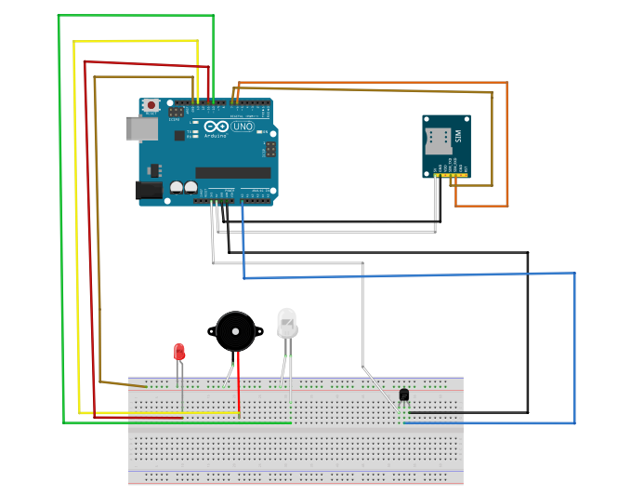

Fig 6.1 : System setup diagram .

After that we connect RX & TX of arduino as shown in the figure , and place them and other element as :

* GSM TX to Pin 6,
* GSM RX to Pin 7,
* Buzzer to Pin 13,
* Red LED to Pin 11,
* Green LED to pin 10,
* Ground to all output devices ground ,

and thus concludes the system setup part .

## System Code

The system code is written on the “Arduino IDE” software and uploaded to the arduino . the full code is given below :

#include <SoftwareSerial.h>

SoftwareSerial SIM900A(6,7);

float temp;

int LEDR = 11;

int LEDG = 10;

int Buzzer = 13;

void setup() {

SIM900A.begin(9600);

Serial.begin(9600);

pinMode(LEDR,OUTPUT);

pinMode(LEDG,OUTPUT);

pinMode(Buzzer,OUTPUT);

}

void loop() {

temp = analogRead(A0);

temp = temp * 0.48828125;

if(temp>34)

{

Serial.println();

Serial.print("** Fire Alert **");

Serial.println();

Serial.println();

digitalWrite(LEDR,HIGH);

digitalWrite(LEDG,LOW);

digitalWrite(Buzzer,HIGH);

Serial.print("Temperature :");

Serial.print(temp);

Serial.print("*c");

Serial.println();

delay(1000);

SendMessage();

}

else {

digitalWrite(LEDG,HIGH);

digitalWrite(LEDR,LOW);

digitalWrite(Buzzer,LOW);

Serial.print("Temperature :");

Serial.print(temp);

Serial.print("*c");

Serial.println();

delay(1000);

}

}

void SendMessage()

{

if (SIM900A.available()>0)

Serial.write(SIM900A.read());

Serial.println ("Making a Call");

SIM900A.println("ATD+8801633325120;");

delay(1000);

Serial.println ("Sending Message");

SIM900A.println("AT+CMGF=1");

delay(1000);

Serial.println ("Set SMS Number");

SIM900A.println("AT+CMGS=\"+8801633325120\"\r");

delay(1000);

Serial.println ("Set SMS Content");

SIM900A.println("2ndfloor,Science Building JKKNIU");

delay(100);

Serial.println ("Finish");

SIM900A.println((char)26);

delay(1000);

Serial.println ("Message has been sent");

delay(5000);

}

From this code we can deduct that, the system will detect fire if the temperature goes above 40°C , then it will enter the if loop , where it will :

1. Turn on the Red LED
2. Turn off the Green LED
3. Turn on the Buzzer
4. Enter the SendMessage(); function where it will send a message to the owner and send a call as a sign of emergency .

Now we have to test how the system works .

# : System Testing

In this chapter of the report we are going to test our designed system for different scenarios to see how well our system reacts . This chapter will describe one of the most important parts of this system . If the testing is done successfully then the system will be considered as an effective and efficient system.

## Testing in case of NO Fire

When there’s no fire the Arduino will turn on only the GREEN LED as , it will enter the else portion of the program , as shown below :

else {

digitalWrite(LEDG,HIGH);

digitalWrite(LEDR,LOW);

digitalWrite(Buzzer,LOW);

Serial.print("Temperature :");

Serial.print(temp);

Serial.print("*c");

Serial.println();

delay(1000);

}

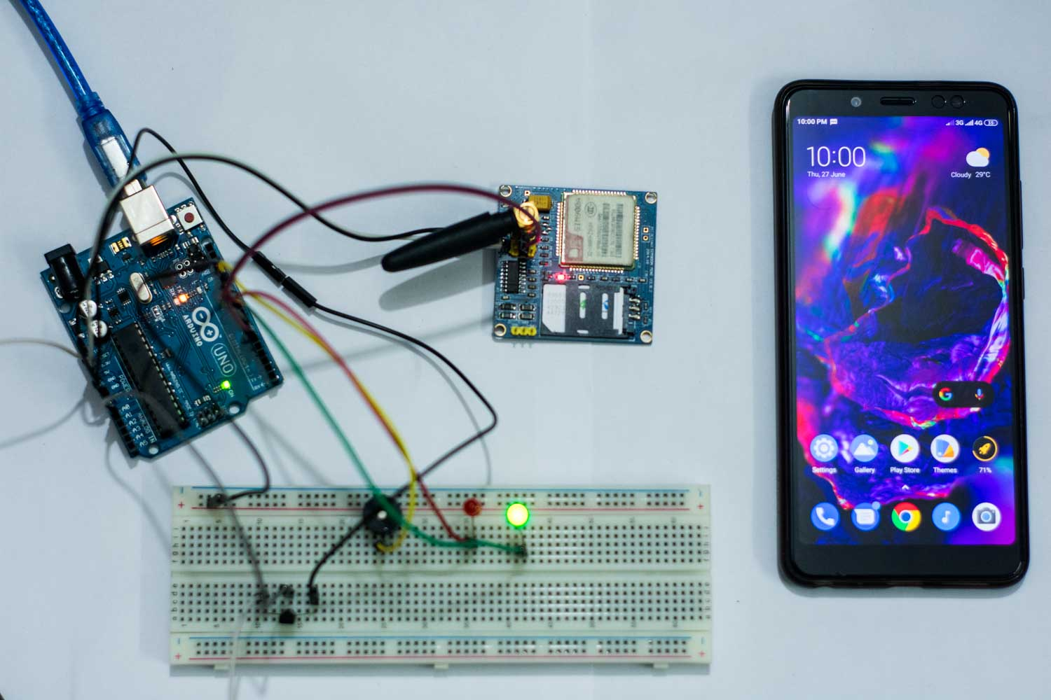

Fig 7.1 : In case of no fire .

From the above picture we can see that when there’s no fire the only the green light lights up , indicating that there’s no fire .

## Testing in case of Fire

In case of fire the if portion of the program works and it detects fire by detecting temperature over **40°C** and entering the loop it turns off the GREEN LED & turn on RED one , and supply power to the BUZZER allowing to alarm people about the fire.

The code :

if(temp>34){

Serial.println();

Serial.print("** Fire Alert **");

Serial.println();

Serial.println();

digitalWrite(LEDR,HIGH);

digitalWrite(LEDG,LOW);

digitalWrite(Buzzer,HIGH);

Serial.print("Temperature :");

Serial.print(temp);

Serial.print("*c");

Serial.println();

delay(1000);

SendMessage();

}

And it also calls SendMessage(); function which allows us to call & send message.

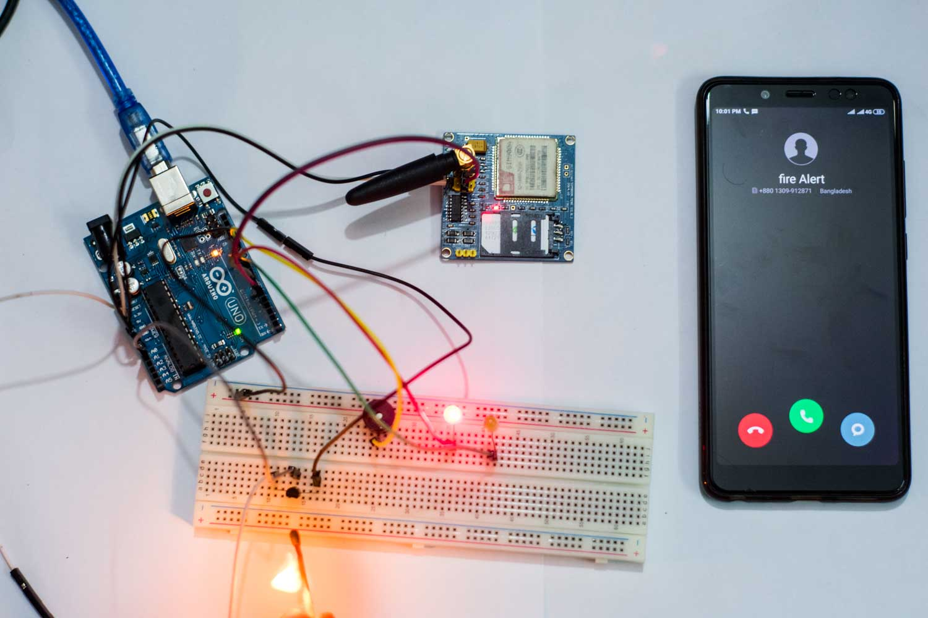

Fig 7.2 : Testing in case of fire .

## Testing for sending SMS to mobile phone

When the Arduino enters the if loop , it calls the SendMessage(); function which is :

void SendMessage(){

if (SIM900A.available()>0)

Serial.write(SIM900A.read());

Serial.println ("Making a Call");

SIM900A.println("ATD+8801633325120;");

delay(1000);

Serial.println ("Sending Message");

SIM900A.println("AT+CMGF=1");

delay(1000);

Serial.println ("Set SMS Number");

SIM900A.println("AT+CMGS=\"+8801633325120\"\r");

delay(1000);

Serial.println ("Set SMS Content");

SIM900A.println("2nd floor, Science Building, J.K.K.N.I.U.");

delay(100);

Serial.println ("Finish");

SIM900A.println((char)26);

delay(1000);

Serial.println ("Message has been sent");

delay(5000);

}

Which allows the arduino to communicate with the GSM module and , with below command we set the arduino to message mode :

SIM900A.println("AT+CMGF=1");

But then we set the SMS number or number of the client using the command :

SIM900A.println("AT+CMGS=\"+8801633325120\"\r");

Then we set the SMS content (Fire alert ) using the below command :

SIM900A.println("2nd floor, Science Building, J.K.K.N.I.U.");

Then we use a command for using all ASCII characters :

SIM900A.println((char)26);

And thus would conclude the part of sending a message .

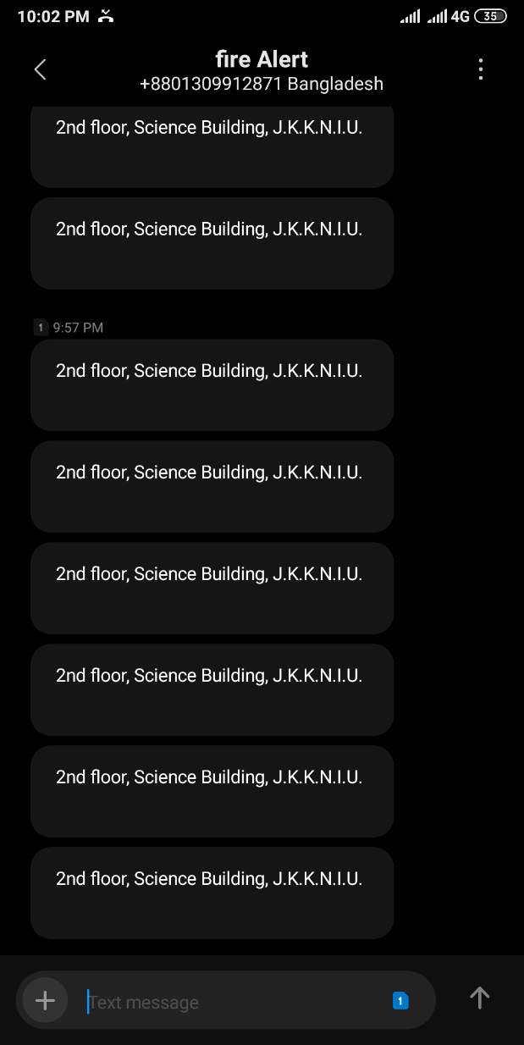

Fig 7.3 : A screenshot of Received message .

## Testing for calling to mobile phone

Now when the Arduino calls the SendMessage(); function , there is also a portion in that function for calling the user and that portion of the code is :

SIM900A.println("ATD+8801633325120;");

With using ATD command we can call a particular number , in this case the number of a project patreon (i.e. The number is +8801633325120).

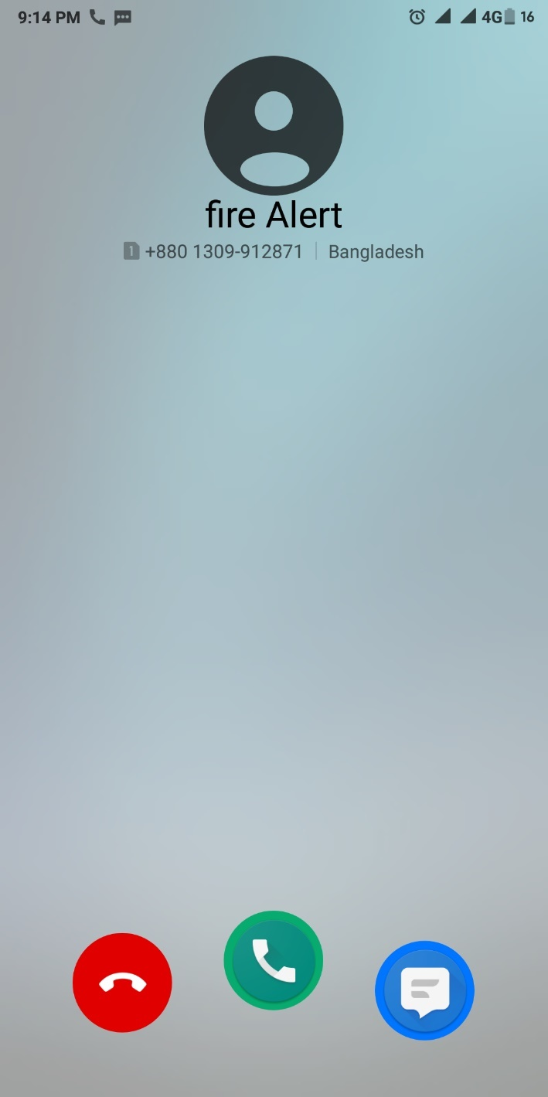

Fig 7.4 : A screenshot of receiving a call from the GSM module .

# : Result & Discussion

We have tested our project in various environment to see how it reacts , as the main objective of our project was to stop fire and prevent the fire in different situation . We have tested with fire in different places like our homes and Varsity . Generally we have generated a small amount of fire by using a lighter to induct fire , then we have tested if the system alerts us about fire .

We have also tested our system by setting different phone numbers to emulate different users, as it could be used by anyone with a cell phone. We have tested with four(4) different cell phone numbers and each number multiple times to see if the system sends SMS and calls the designated number in case of fire, & the results are:

|  |  |  |  |
| --- | --- | --- | --- |
| Phone Number | Testing Times | Successfully Triggered | Average Elapsed time (Minute) |
| 01732226402 | 50 | 49 | 1 |
| 01633325120 | 40 | 38 | 1 |
| 01777200243 | 30 | 29 | 1 |
| 01784103680 | 20 | 20 | 1 |

Table 8 : Result of system testing .

From here we can say that 98% of the time our developed system successfully triggered the alert operation. Hence, it’s a perfect system to be used for practical case.

# : Conclusion

The “An Arduino and GSM Based Fire alert system” was designed for alerting people in case of fire on their property, and stop casualties caused by fire related accident . And GSM network played an integral part of this project as it has provided us with a readily available network system that is usable and connects most of the people using a cell phone .

## Scope

As this project is GSM based and for warning about fire so it’s essential to alert the users by calling or sending message. It shows the instant alert in the LED light. when it is green, there is no fire in the room and when it is red ,it indicates fire. It’s give instant warning .The project also have a buzzers that sounds on when fire is occurred. It makes fire safety an accessible to even the poor people as it’s very cost efficient .It’s an cheap and effective invention that lets people to secure themselves from fire .

## Limitation

In this project we have used Temperature sensor to detect fire , but it’s not an efficient way to detect fire as it can give false alert in very hot days or very hot surroundings .

we can eliminate this defect by using a flame sensor, but it will be less cost efficient.

## Future Development

For future development we can use Flame sensor instead of Temperature sensor , which will give us an accurate reading of flame thus increasing the efficiency of the system .

for mass production we can use Printed Circuit Board(PCB) to design the system cheaply and efficiently .

## In Summary

The system has been designed and developed to make our life feel easier and secured. We use 5V from Arduino Uno board and use a GSM module. We use the GSM module(SIM900A) for receiving signal from an Arduino and used a temperature sensor to detect fire. Finally, we have developed the whole system and tested in real scenarios. We have fixed all the problems encountered during the designing and testing period of the system. Finally, we have successfully achieved our goals. In this study, the application of microcontroller with improved algorithm of extended specifications has increased the use of GSM module and improves the efficiency of the system .

So, we can say that our project **“**AN ARDUINO AND GSM BASED FIRE ALERT SYSTEM” is a success.

# ****References****

1. Asha K. Mehrotra , “*GSM System Engineering Series*” .
2. Michel Mouly and Marie-Bernadette Pautet, “*GSM System for Mobile Communications*”, 1992, ISBN 2-9507190-0-7
3. Friedhelm Hillebrand, “*GSM and UMTS, the creation of Global Mobile Communication*”, Wiley 2001
4. Timo Halonen, Javier Romero, Juan Melero, “*GPRS and EDGE Performance: Evolution Towards 3G/UMTS*” .
5. Joerg Eberspaecher, Hans-Joerg Voegel, Christian Bettstetter*,”GSM Switching, Services, and Protocols” .*
6. <https://www.thedailystar.net/star-infrastructure/news/fire-safety-issues-buildings-dhaka-city-1722730>
7. <http://www.wikipedia.com>
8. <https://www.worldometers.info/world-population/bangladesh-population/>
9. Arduino - Software. 2013. Arduino - Software. [ONLINE] Available at: <http://arduino.cc/en/Main/Software>
10. Hardware module specification : <http://techshopbd.com/>